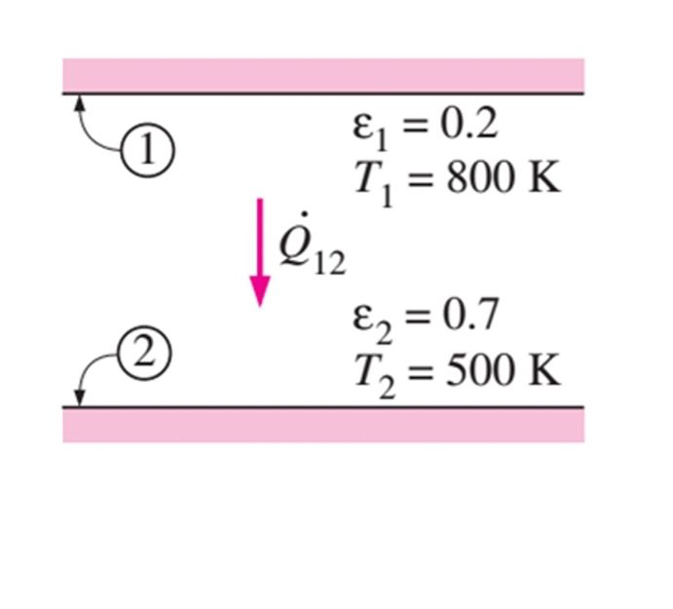

=

= = 3625.42

THE NUMBER OOF SHEETS WITH = 0.1

3625.42 \* %1 = 36.25

= =

= = 36.25

= 36.25

19680.57= 36.25(5.42+19n)

542.91-5.42=19n n= 28.1

28 SHEETS WITH 0.1 WE NEED TO DECREASE THE RADIATION HEAT TRANSFER AND REACH TO THE 1%

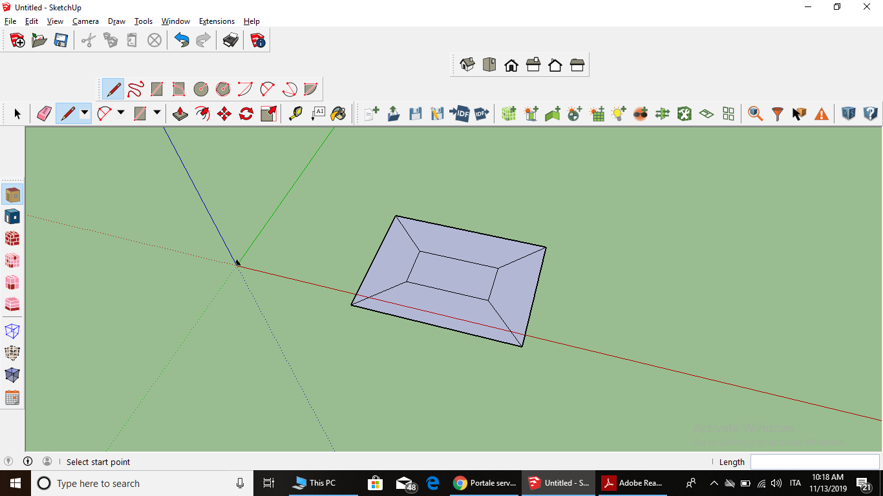

I draw a rectangle with offset

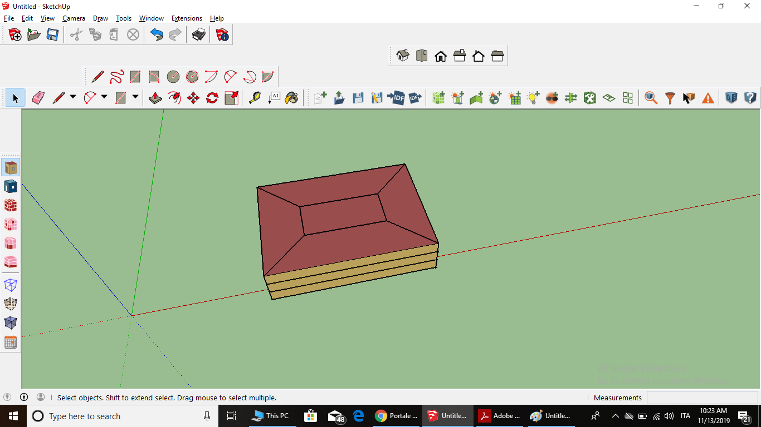

I need to have 3floor and my floor height is 3 then I click create spaces from diagram and I can see the information with info tool

I used surface matchin for understanding interior and outer walls

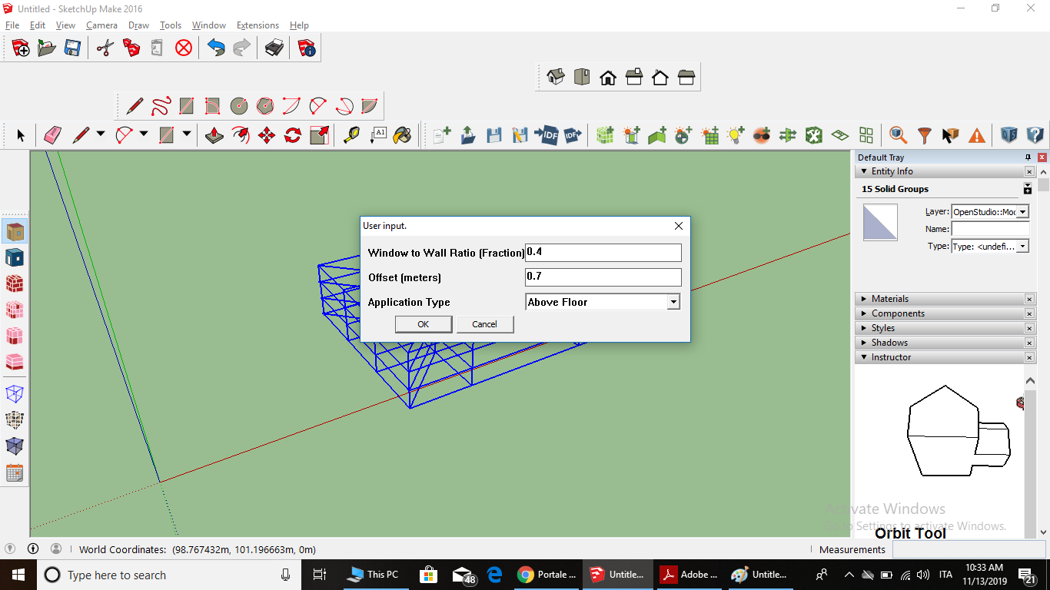

I added the window with %70 proportion

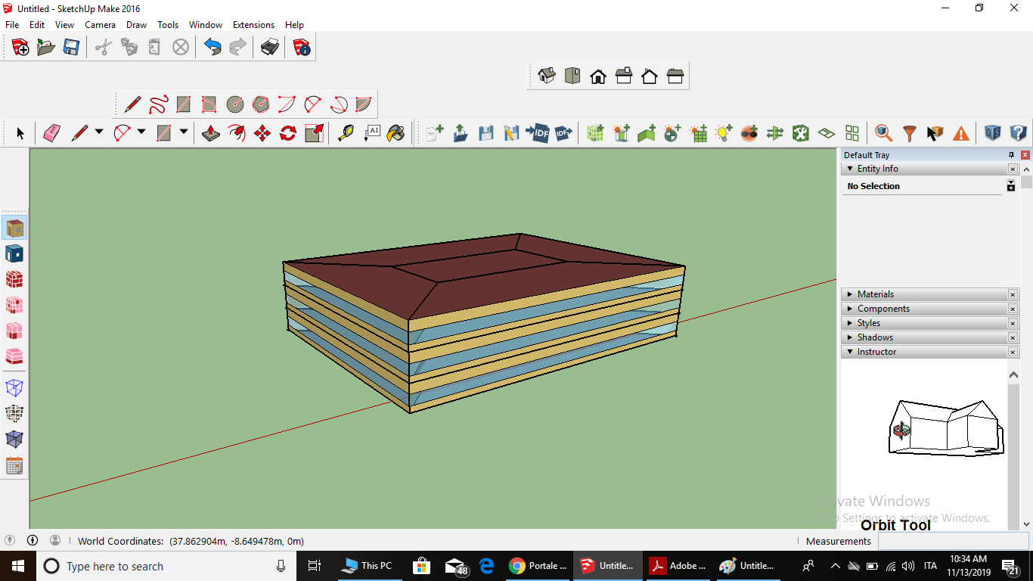

Well, I created the building with window

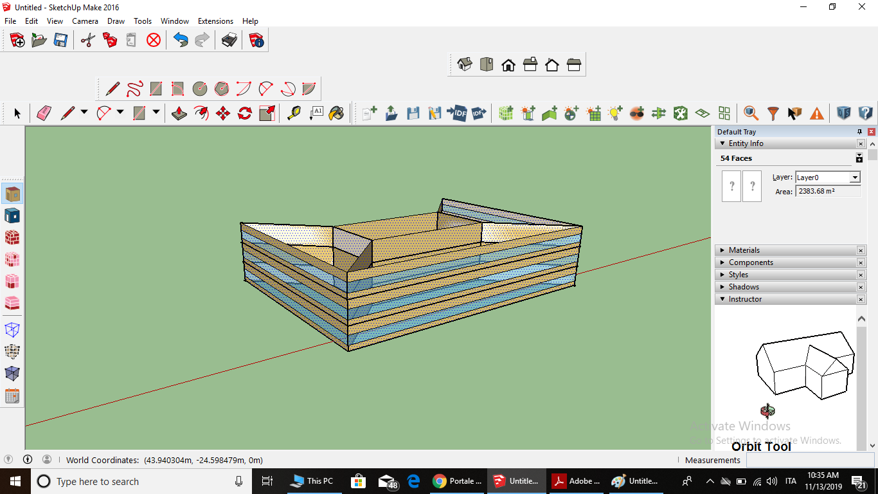

For creating shading I selected all except the north for example: 45-270

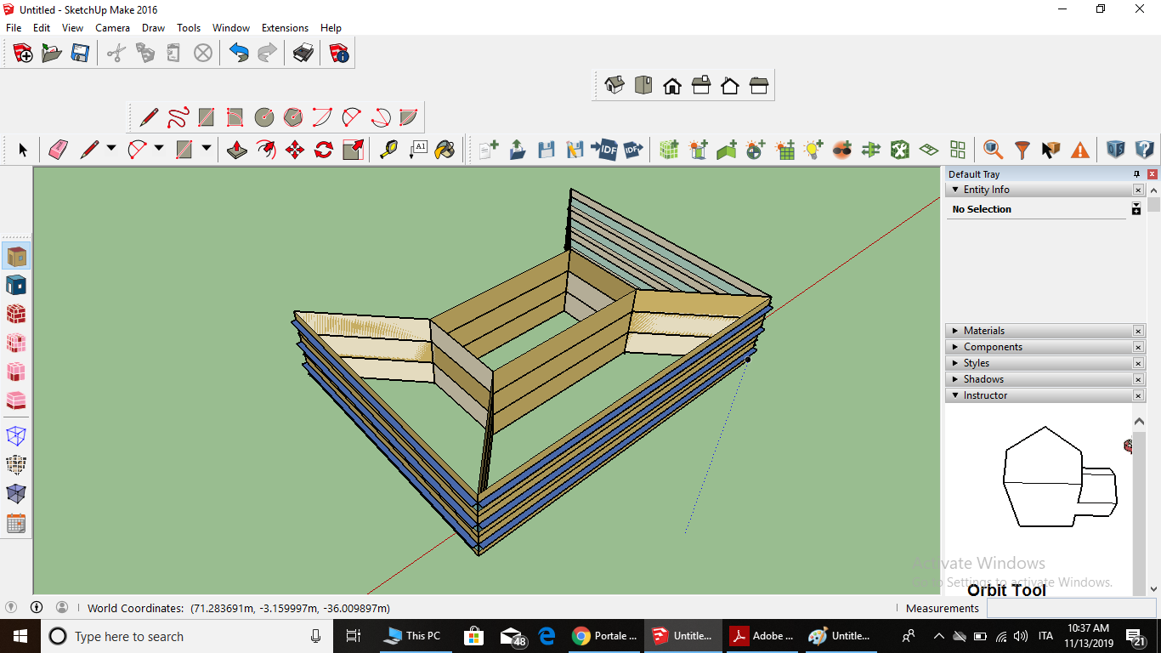

I wanted to add overhangs so I used extensions

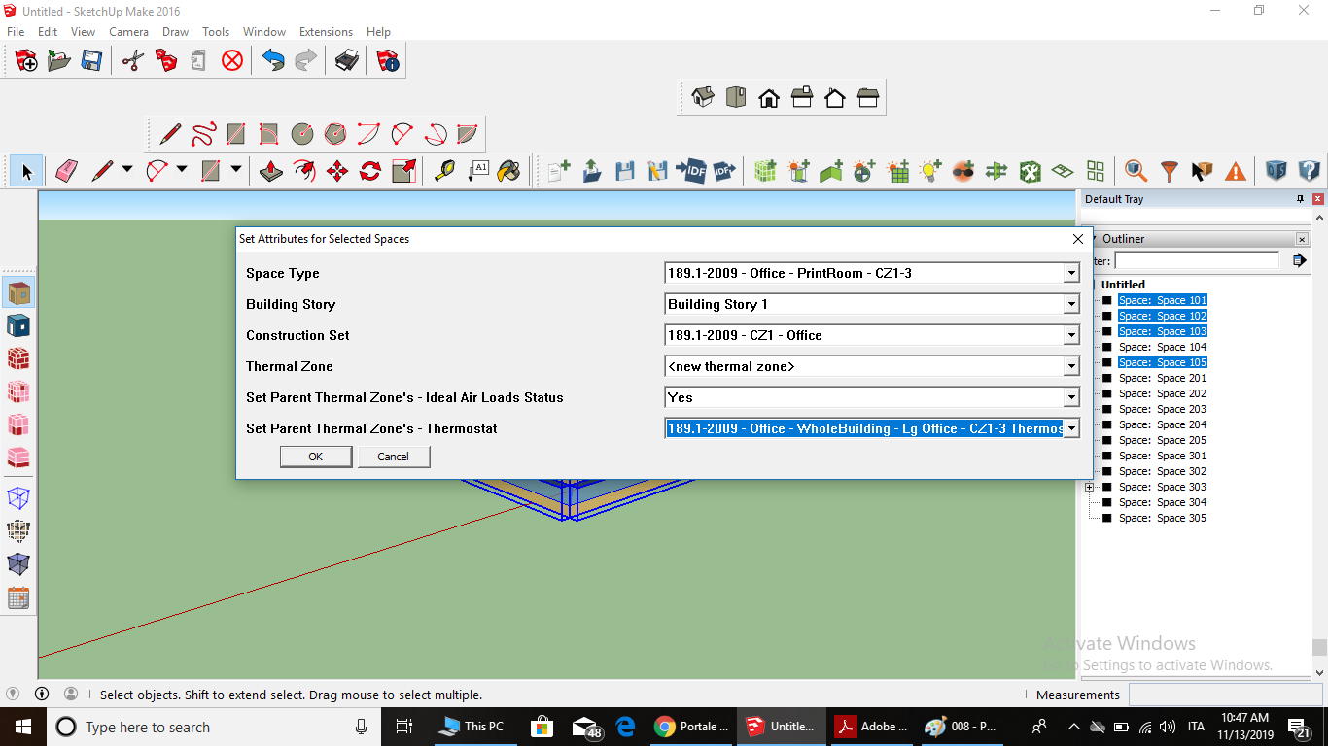

I chaos spaces to define thermal zone and saved it.

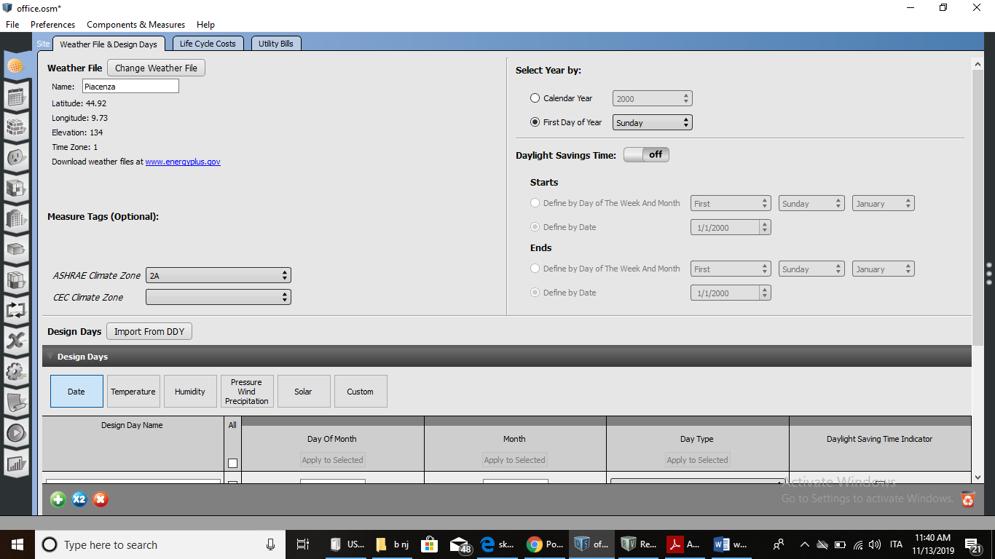

I opened the open studio and imported the day and weather so I run my file and this is my result

